**CS403 Assignment #1 Spring 2022**

***Name: Abdul Rehman.***

***VU-ID: BC200403287.***

**Question Statement:**

Suppose you are required to model an “E-Furniture Store” system for an organization to get complete understanding of the domain. This E-Furniture system provides the distribution of furniture to all over the country.

System’s requirements in textual format is given below in paragraphs.

The system will display the available items types such as sofa_set, chairs, bed_set etc along with their respective item images, names, prices, number of items available in stock and related description.

Anyone can view available items however only clients (registered individual **users** or **distributor**) can interact with website. Clients will be able to purchase **items** available on website, they can also place a **customized order** for items with their own choice of materials, fabrics, description, wood type, number of items etc. Clients can also specify required completion data for customized **order**. Clients will also be able to view and download the **invoice**.

**Manger** can view order details and can process the orders. He/She can also generate invoice. Manager also wants to keep record of available **stock**.

Manager can allocate customized order to carpenters and can view allocated order details. **Carpenters** will be able to view allocated customized order detail, they can also update the status of the order.

**Solution:**

**You are required to perform the following tasks according to the above scenario.**

* Identify all valid Entities.
* *User.*
* *Distributor.*
* *Items.*
* *Customized order.*
* *Order.*
* *Invoice.*
* *Manger.*
* *Stock.*
* *Carpenter.*
* Draw the Entity Relationship Diagram (ERD).
* Draw relationship cardinalities in alphabetical notation.

**Note:**

>> Website I used to draw ERD: https://app.diagrams.net/

>> Please Zoom In for better understanding.

**Screenshot:**

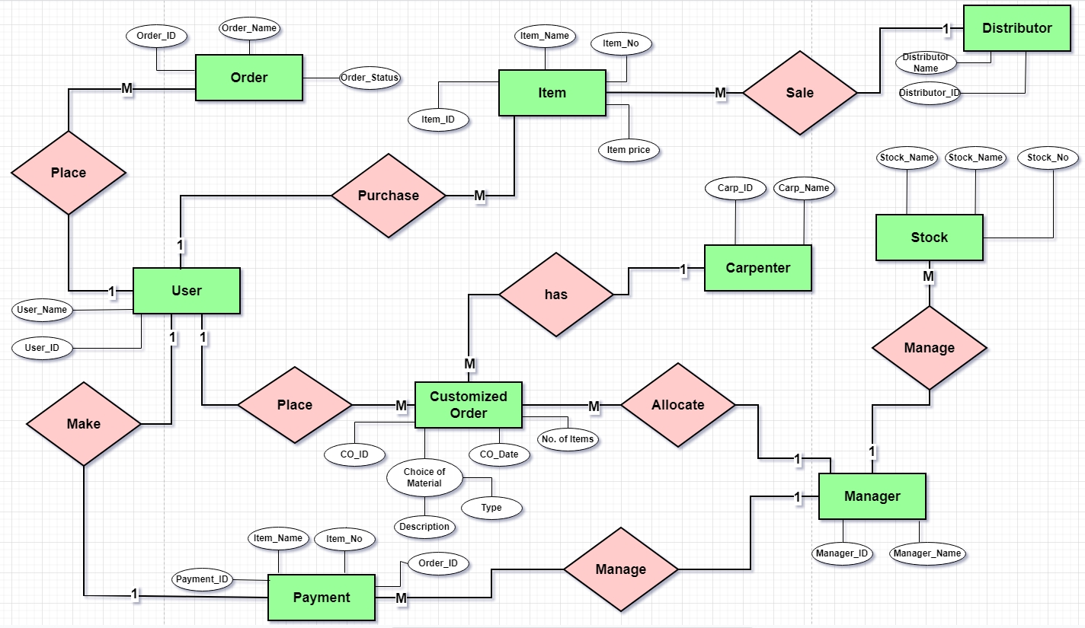

**JPEG:**

